Is there a social stigma against working wives?
Isaac Lopez-Moreno

Online Appendix

Appendix A: Descriptive statistics

Table 1.1 – Descriptive statistics of the dependent variables

Table 1.2 – Descriptive statistics of variables capturing individual characteristics

Table 1.3 – Descriptive statistics of variables capturing household characteristics
Notes:
The variable ‘Partner’s level of education’ is only used in the third stage of the econometric analysis.
For working-age women, it captures their husbands' educational attainment.
For working-age men, it captures the level of education of their wives.

Table 1.4 – Descriptive statistics of the sample by year/quarter and state
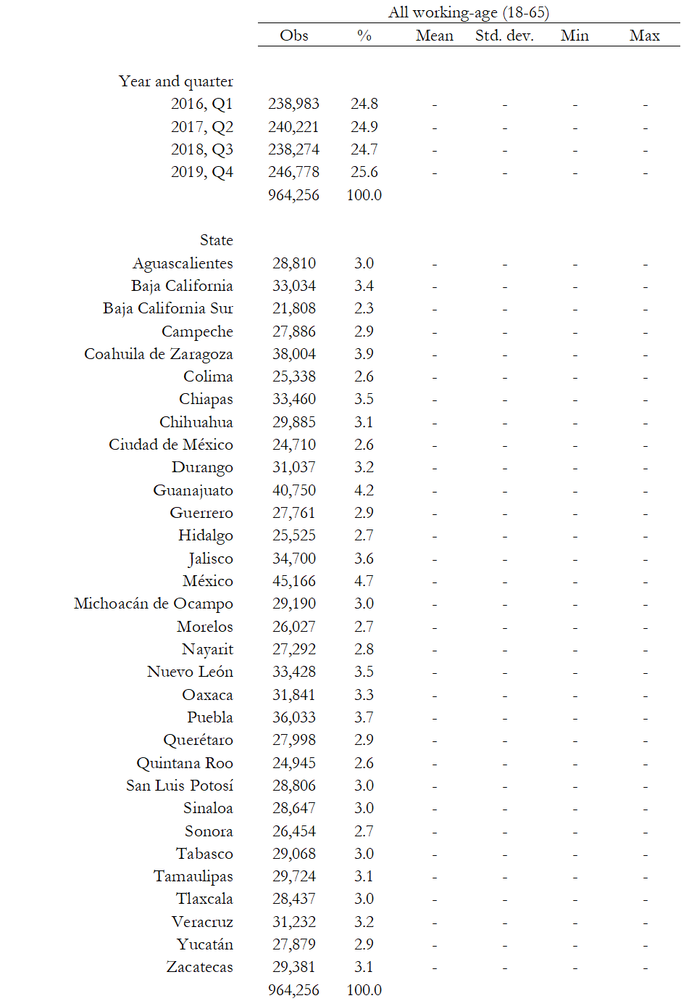

Appendix B: Figures and Tables

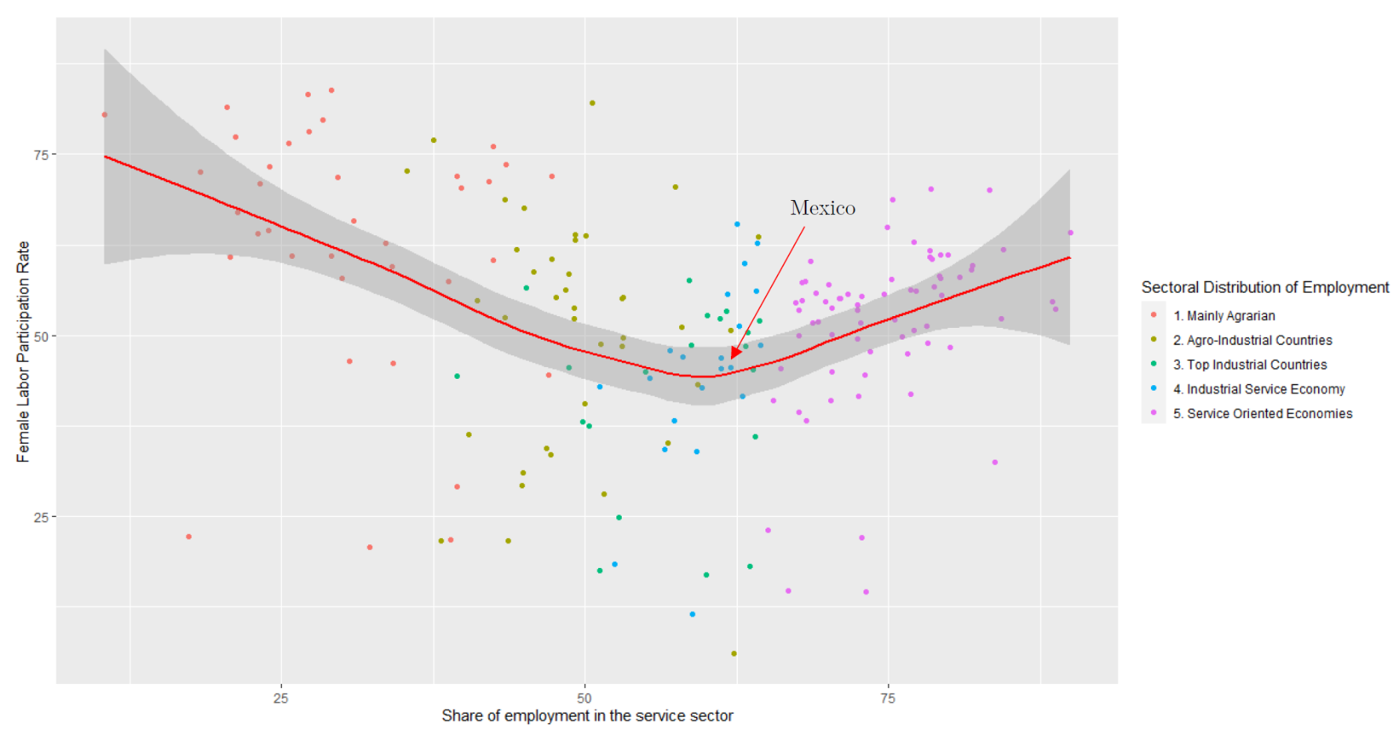
Figure 1.7 – U-shaped relationship of FLPRs at different stages of economic development across countries (2019)
Notes:
- Countries with the highest proportion of jobs in agriculture are on the left-hand side of the Figure.
- Countries are classified as mainly agrarian if their agricultural sector accounts for 40% to 80% of their total jobs.
- In the centre of the figure are the top industrial countries, with over 30% of their jobs in industry.
- On the right-hand side are the service-oriented countries, with at least 65% of their jobs in services.
- Agro-industrial countries have 25% to 40% of their jobs in agriculture and fewer than 30% in industry.
- Industrial-service economies have more than 50% of jobs in services and fewer than 30% in industry.
- Data Sources: World Bank Development Indicators.
- Employment in services (% of total employment) (modeled ILO estimate)
- Labor force participation rate female (% of female population ages 15+) (modeled ILO estimate)

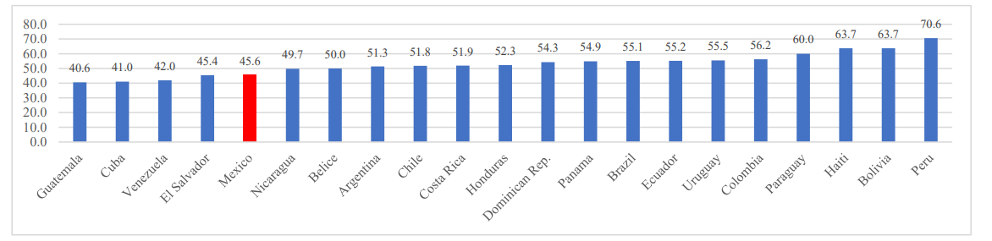
Figure 1.8 – FLPRs in Latin American countries (2019)
Source: World Bank, WDI – Female labor participation (% of female population ages 15+).

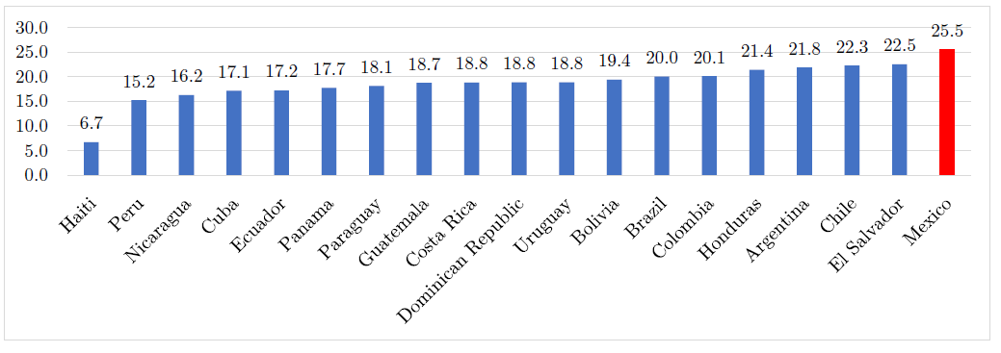
Figure 1.9 – Industrial jobs as a share of total employment in Latin American countries (2019)
Source: World Bank, WDI – Employment in industry (% of total employment).

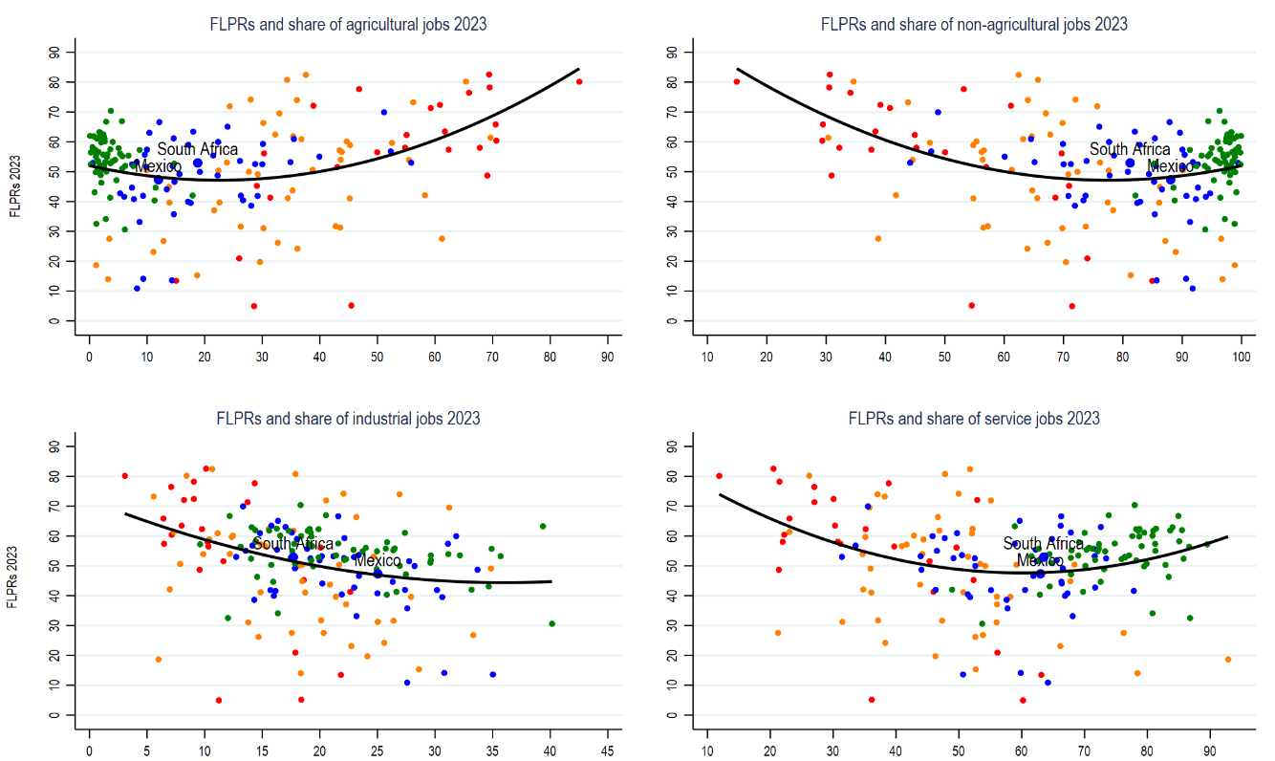
Figure 1.10 – Female labour participation rates and sectoral shares of employment across countries (2023)

Notes:
Income group classification: Red = low income; Orange = lower-middle income; Blue = upper-middle income; Green = High income.
Data obtained from the World Bank Development Indicators.

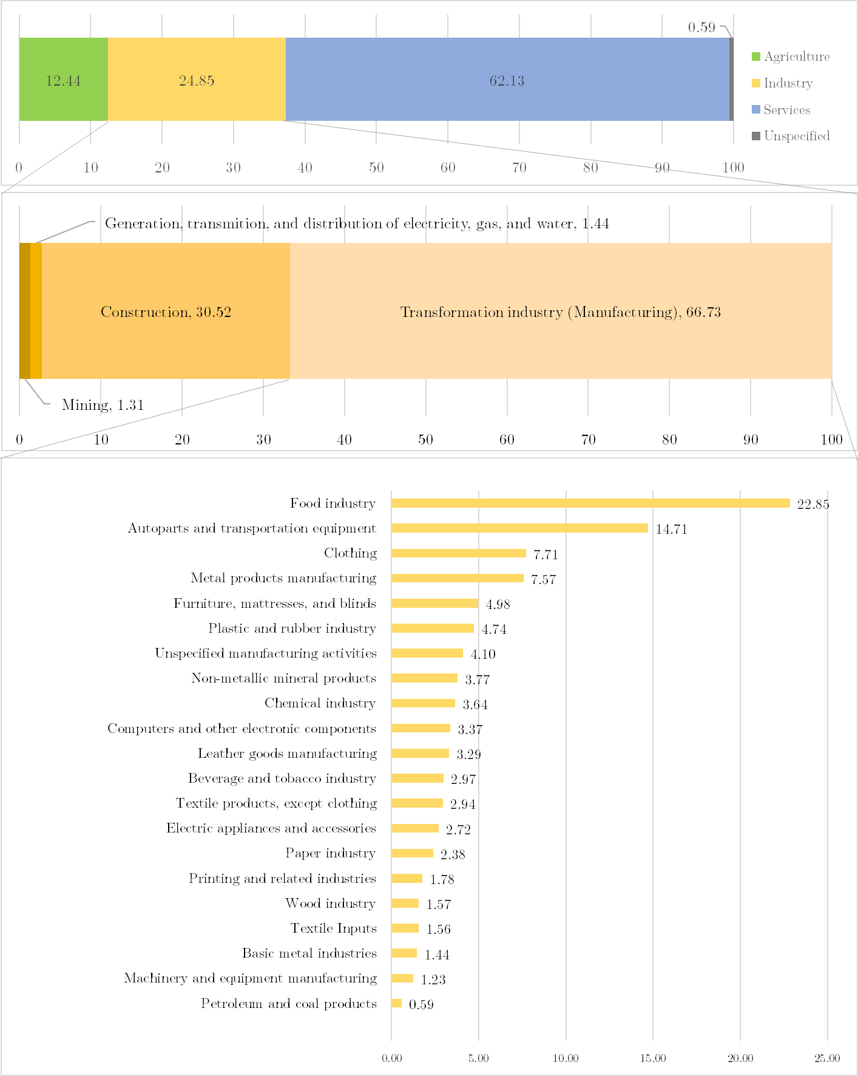
Figure 1.11 – Sectoral composition of employment in Mexico: industry and manufacturing disaggregated (2019, Q4)

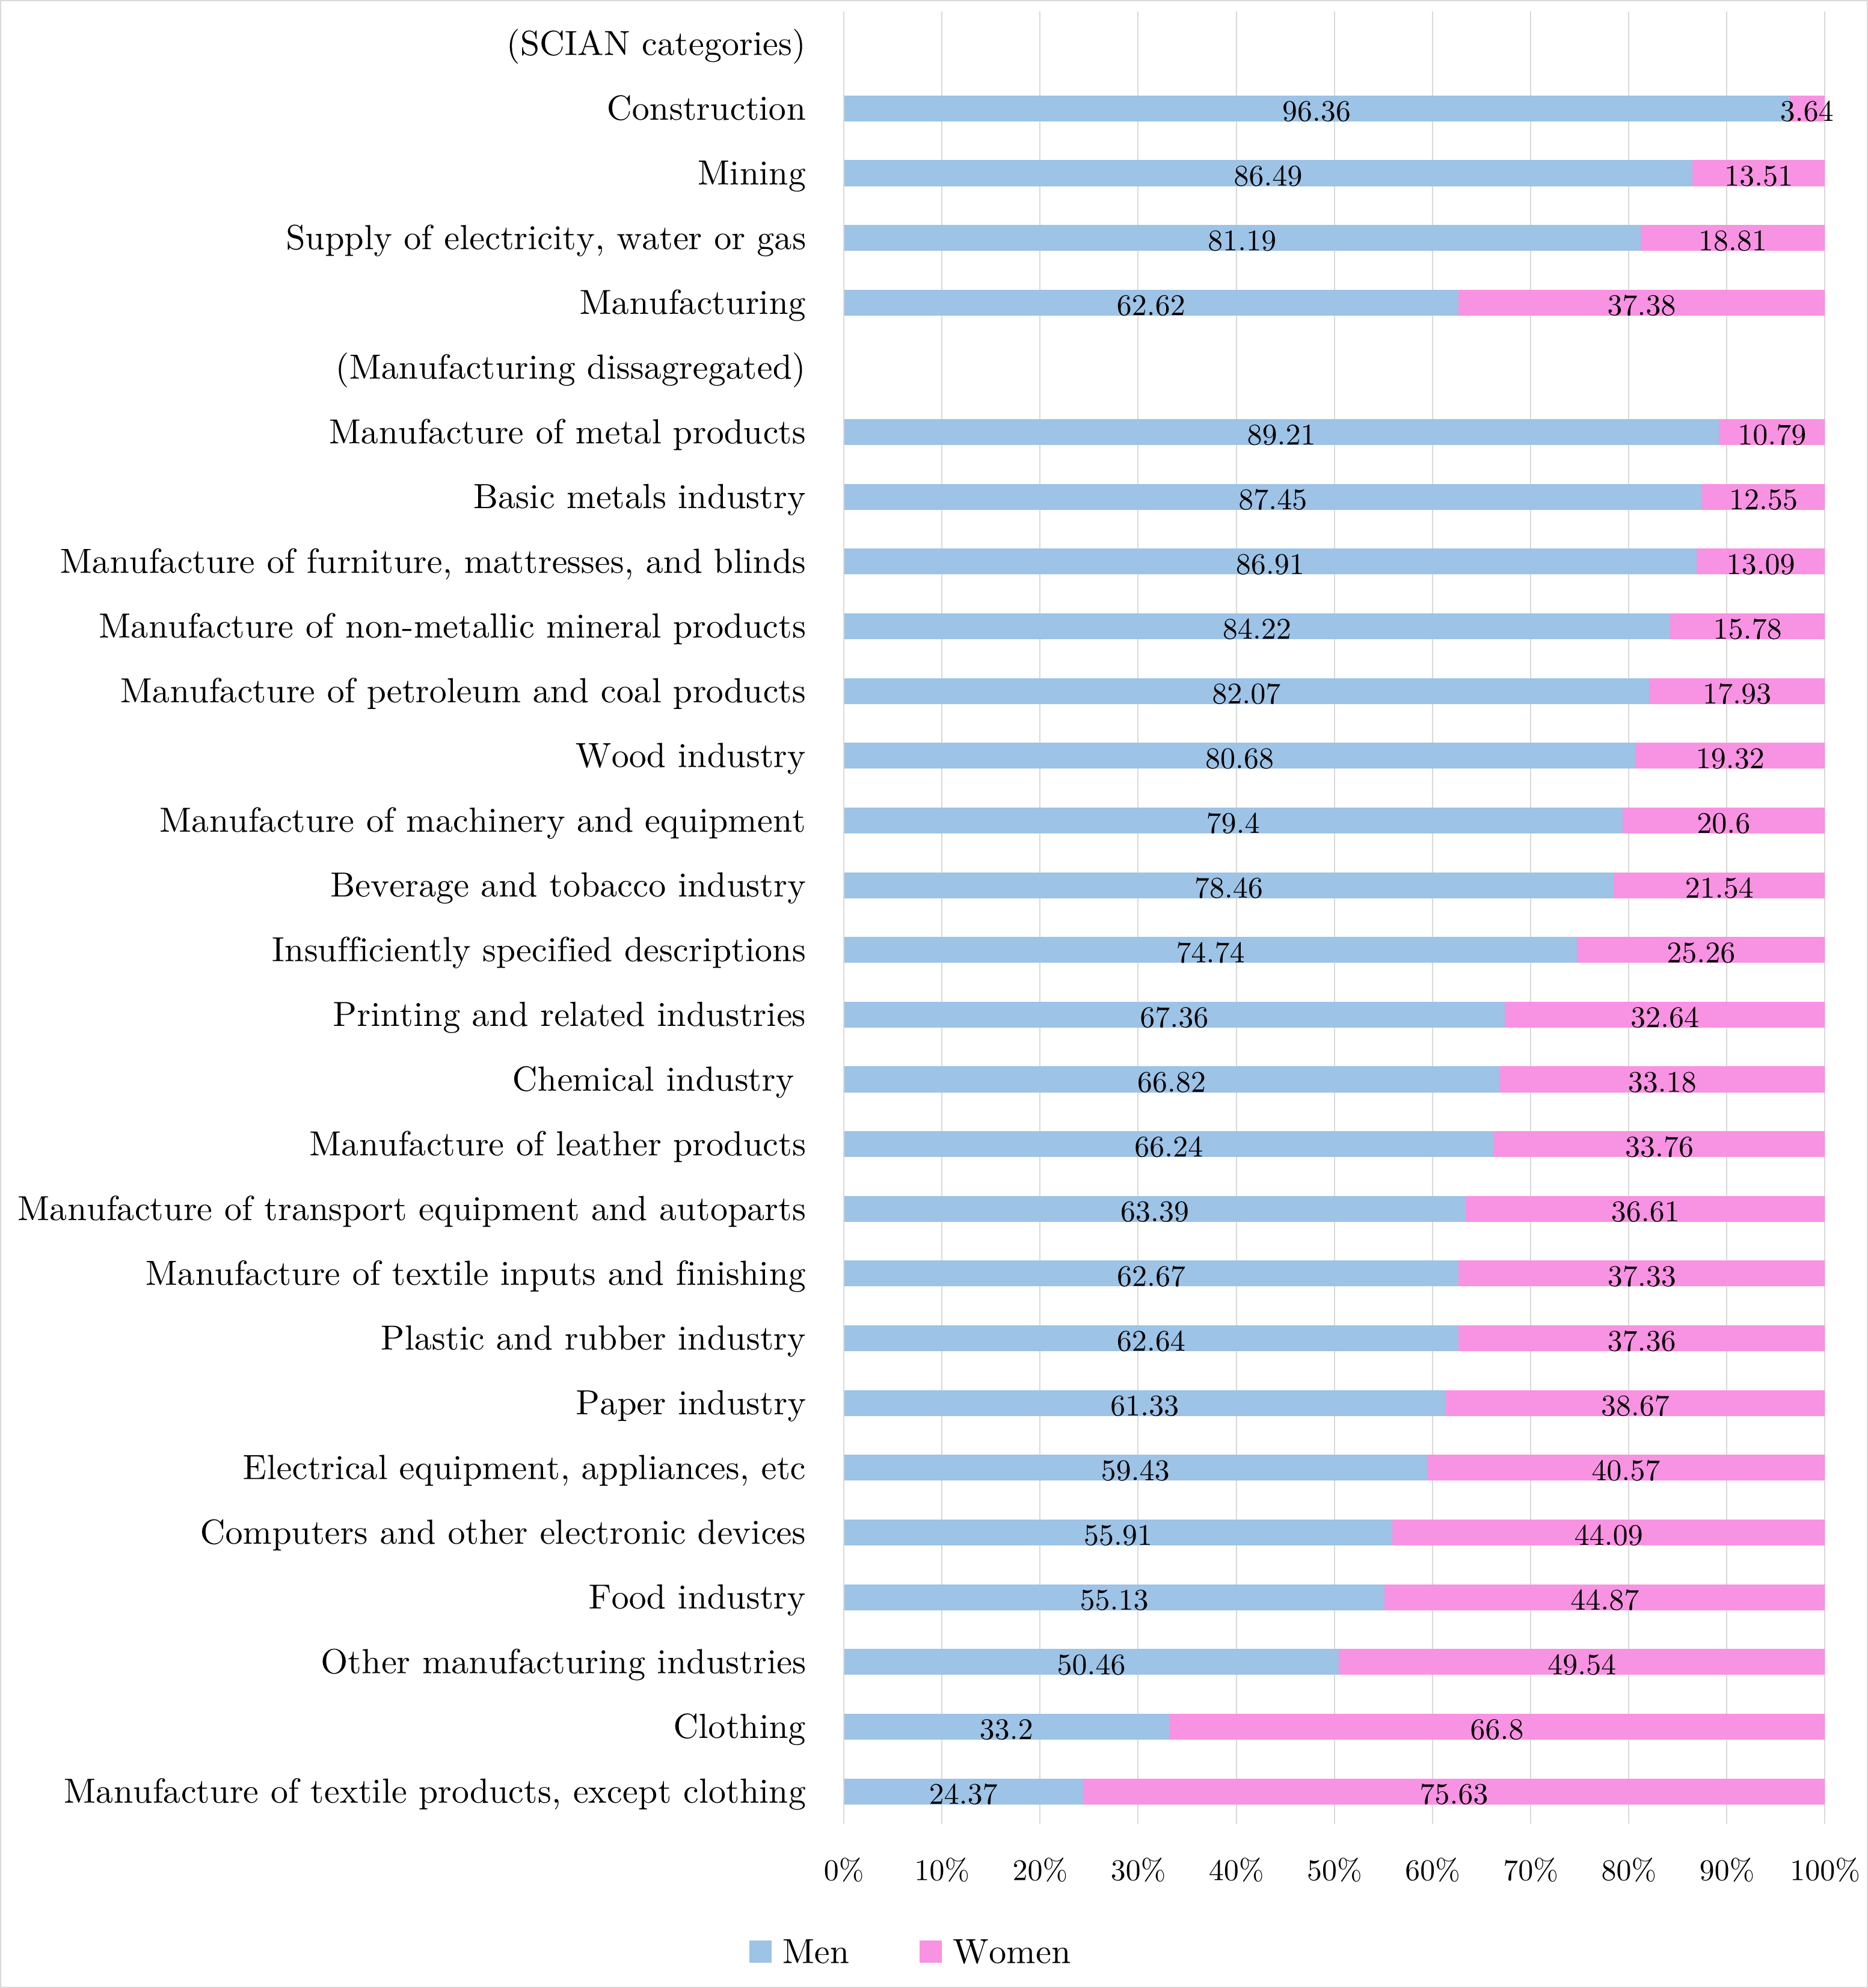
Figure 1.12 – Proportion of men and women working in different economic activities within the industrial sector (Mexico, Q4 2019)

Table 1.5 – Distribution of female workforce across economic activities within the industrial sector (2019, fourth quarter)
Economic activity | Percentage | Female workers
Food industry | 24.88 | 868,425
Auto parts and transportation equipment | 14.26 | 497,798
Clothing | 12.77 | 445,803
Unspecified manufacturing activities | 5.18 | 180,636
Textile products, except clothing | 5.13 | 179,082
Plastic and rubber industry | 4.53 | 157,939
Construction | 4.40 | 153,512
Computers and other electronic devices | 3.91 | 136,445
Chemical industry | 3.19 | 111,451
Electrical appliances and accessories | 2.90 | 101,109
Leather goods manufacturing | 2.80 | 97,772
Paper industry | 2.30 | 80,254
Metal products manufacturing | 2.16 | 75,495
Furniture, mattresses, and blinds | 1.69 | 58,842
Beverage and tobacco industry | 1.64 | 57,085
Printing and related industries | 1.53 | 53,498
Non-metallic mineral products | 1.46 | 50,911
Textile Inputs | 1.34 | 46,859
Supply of electricity, water, or gas | 1.08 | 37,577
Mining | 0.70 | 24,423
Timber industry | 0.69 | 24,160
Machinery and equipment manufacturing | 0.67 | 23,479
Basic metal industries | 0.47 | 16,285
Petroleum and coal products | 0.28 | 9,811
Total | 100.00 | 3,488,651

Table 1.6 – Marital status of working-age women in Mexico
 | Year / Quarter
Marital status | 2016, Q1 | 2017, Q2 | 2018, Q3 | 2019, Q4
Married | 45.69% | 44.29% | 43.70% | 42.08%
Single | 26.19% | 26.53% | 26.91% | 27.66%
Free union | 17.09% | 18.18% | 18.20% | 18.98%
Separated | 5.23% | 5.35% | 5.27% | 5.38%
Widowed | 3.76% | 3.61% | 3.73% | 3.73%
Divorced | 2.04% | 2.04% | 2.18% | 2.16%

Table 1.7 – Main reason for leaving your last job (first quarter of 2016)
Notes:
- The most popular response for men and for women is highlighted in bold.
- The population estimates were calculated using the probability weights of each person in the sample.
- This question is part of the extended ENOE questionnaire, which is administered only during the first quarter of each year.

Figure 1.13 – Reasons why women dedicated to household chores are not working. (Mexico, 2019)
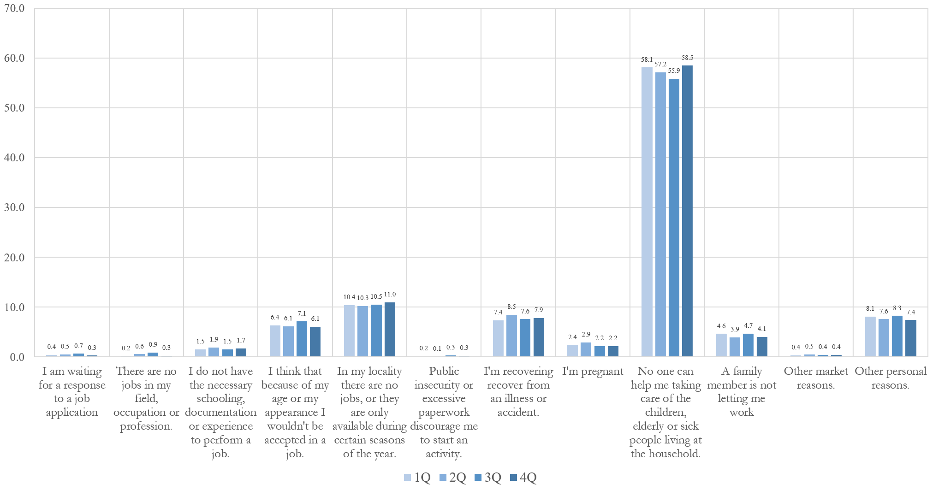

Notes: In Mexico, there are four categories for classifying individuals who are not participating in the labour force: (1) people dedicated to household chores; (2) students; (3) retirees and pensioners; and (3) people who are permanently disabled. This figure focuses on the responses of women who are dedicated to household chores, thereby excluding students, retirees, and individuals with permanent disabilities from the analysis.

Appendix C: Regression results

Table 1.8 – First stage: Multinomial probit regression to estimate men’s and women’s likelihood of working in agriculture, industry, informal services or formal services depending on marital status
Notes:
- Columns 1 to 4 report multinomial probit estimates for working-age women (18–65), taking those who are not working as the baseline category.
- Columns 5 to 8 report multinomial probit estimates for working-age men (18–65), taking those who are not working as the baseline category.
- Regressions were run using probability weights.
- Base category for time fixed effects (2016, Q1).
- Base category for state fixed effects (Mexico City).
- Standard errors in parentheses.
- *** p<0.01, ** p<0.05, * p<0.10
Table 1.9 – First stage: Predicted probabilities of men and women working in different economic sectors depending on their marital status

Notes:
- These estimations are model-based predictions obtained from the multinomial probit regressions fitted in the first stage of the econometric analysis.
- To obtain these predicted probabilities, all covariates included in the multinomial probit regressions are held at their respective mean values.
- Standard errors in parentheses.
- *** p<0.01, ** p<0.05, * p<0.1

Table 1.10 – Second stage: Probit regressions to estimate wives’ likelihood of working in different industries, white-collar activities,
white-collar occupations, and different service jobs requiring high-brain-skills and low-brain-skills (compared with single women).
Notes:
- Regressions 1 to 4 correspond to: (1) mining, (2) iron and steel, (3) food processing, and (4) clothing and textiles. These categories were constructed using the NAICS classification system.
- Regressions 5 to 7 correspond to: (5) education, (6) health, and (7) finance. These categories were defined using the NAICS classification system.
- The NAICS classification system is used by Mexico, the USA, and Canada to classify workers according to the characteristics of the economic activity of the firm in which they are employed.
- NAICS is divided into three sectors: agriculture, industry, and services. It then breaks these down into 20 subsectors, including mining, manufacturing, financial services, health, education, as well as others.
- NAICS subsectors can be further disaggregated into economic activities. For instance, iron and steel, food processing, and clothing and textiles are industrial activities in the NAICS system.
- The NAICS is based on firm characteristics. Thus, administrative workers in a mining company are considered workers in the mining industry.
- To address this limitation of the NAICS, this study also uses the SINCO classification system, which classifies employees based on their job characteristics, rather than the characteristics of the firms where they work.
- An explanation of how each variable was constructed using the NAICS and SINCO can be found in the methodology section, specifically in the subsection devoted to the second stage of the econometric analysis.
- Additional details on NAICS and SINCO can be found in the online appendix.
- The lower number of observations for architects (column 11), lawyers (column 12), and doctors (column 14) reflects the fact that these occupations require university-level qualifications as a prerequisite for professional practice. Consequently, the sample for these regressions is automatically restricted to people with university degrees, thereby representing a subset of the broader population.
Table 1.11 – Second stage: Probit regressions to estimate husbands’ likelihood of working in different industries, white-collar activities,
white-collar occupations, and different service jobs requiring high-brain-skills and low-brain-skills (compared with single men).
Notes:
- Regressions 1 to 4 correspond to: (1) mining, (2) iron and steel, (3) food processing, and (4) clothing and textiles. These categories were constructed using the NAICS classification system.
- Regressions 5 to 7 correspond to: (5) education, (6) health, and (7) finance. These categories were defined using the NAICS classification system.
- The NAICS classification system is used by Mexico, the USA, and Canada to classify workers according to the characteristics of the economic activity of the firm in which they are employed.
- NAICS is divided into three sectors: agriculture, industry, and services. It then breaks these down into 20 subsectors, including mining, manufacturing, financial services, health, education, as well as others.
- NAICS subsectors can be further disaggregated into economic activities. For instance, iron and steel, food processing, and clothing and textiles are industrial activities in the NAICS system.
- The NAICS is based on firm characteristics. Thus, administrative workers in a mining company are considered workers in the mining industry.
- To address this limitation of the NAICS, this study also uses the SINCO classification system, which classifies employees based on their job characteristics, rather than the characteristics of the firms where they work.
- An explanation of how each variable was constructed using the NAICS and SINCO can be found in the methodology section, specifically in the subsection devoted to the second stage of the econometric analysis.
- Additional details on NAICS and SINCO can be found in the online appendix.
- The lower number of observations for architects (column 11), lawyers (column 12), and doctors (column 14) reflects the fact that these occupations require university-level qualifications as a prerequisite for professional practice. Consequently, the sample for these regressions is automatically restricted to people with university degrees, thereby representing a subset of the broader population.

Table 1.12 – Third stage: Multinomial probit regression to estimate wives' and husbands' likelihood of working in
agriculture, industry, informal services or formal services depending on their partner’s education.

Notes:
- These results were obtained using a multinomial probit regression.
- The dependent variable comprises five categories: (0) not working, (1) employed in agriculture, (2) employed in industry, (3) employed in informal services, and (4) employed in formal services.
- The analysis uses category 0 (not working) as the base outcome.
- The regression table does not report estimates for category 5 (unspecified activities) because it contains only a few observations and is not relevant to the analysis.
- The regression excludes single, separated, divorced, and widowed women/men, and retains only those who are married or in free-union partnerships.
- Standard errors in parentheses
*** p<0.01, ** p<0.05, * p<0.1

Table Error! No text of specified style in document..1 – Predicted probability of wives working in different sectors depending on the education level of their husbands

Table Error! No text of specified style in document..2 – Predicted probability of husbands working in different sectors depending on the education level of their wives

Notes:
- These estimations are model-based predictions obtained from the multinomial probit regressions fitted in the third stage of the econometric analysis.
- To obtain these predicted probabilities, all covariates included in the multinomial probit regressions are held at their respective mean values.
- Standard errors in parentheses.
- *** p<0.01, ** p<0.05, * p<0.1

Appendix D: Classification systemts (NAICS & SINCO)

This online appendix includes the classification systems used in Mexico’s ENOE survey. It begins with an explanation of NAICS, followed by an explanation of SINCO.

NAICS Classification System

The NAICS Classification System is used in Mexico, the United States, and Canada. It is based on the characteristics of the firm where the surveyed individuals work. The system is organised into three broad economic sectors: agriculture, industry, and services. It can also be disaggregated into 21 subsectors and, at the finest level of detail, into 181 economic activities. Below is a list of the 21 subsectors and the economic activities that comprise each subsector.

It is important for the reader to note the following. The list of economic activities presented here was obtained directly from INEGI (2015). The ENOE survey includes variables to identify in which economic sector (3 options), in which subsector (21 options), and in which economic activity (181 options) each worker is employed. To assist readers unfamiliar with Spanish, this list has been translated using artificial intelligence and is included for reference purposes. For additional details, verification, or precise definitions of the categories listed below, please refer to the original Spanish documentation from INEGI (2015).

1 - Agriculture, Animal Breeding and Production, Forestry, Fishing and Hunting
- 1110 Agriculture
- 1121 Animal breeding and production
- 1122 Aquaculture
- 1130 Forestry
- 1141 Fishing
- 1142 Hunting and trapping
- 1150 Services related to agricultural and forestry activities
- 1199 Insufficiently specified descriptions of subsectors within Sector 11

2 - Mining
- 2110 Oil and gas extraction
- 2121 Coal mining
- 2122 Metallic mineral mining
- 2123 Non-metallic mineral mining
- 2129 Insufficiently specified descriptions of metallic and non-metallic minerals
- 2131 Mining-related services
- 2132 Drilling of oil and gas wells
- 2199 Insufficiently specified descriptions of subsectors within Sector 21

3 - Generation, Transmission and Distribution of Electricity, Water and Gas Supply
- 2210 Electricity generation, transmission and distribution
- 2221 Water collection, treatment and supply
- 2222 Gas supply through pipelines to the final consumer

4 - Construction
- 2361 Residential building construction
- 2362 Self-built residential construction
- 2363 Non-residential building construction
- 2370 Civil engineering works construction
- 2381 Specialised construction work
- 2382 Masonry, plumbing, electrical installations, and outdoor construction work
- 2399 Insufficiently specified descriptions of subsectors within Sector 23

5 - Manufacturing Industries
- 3110 Food industry
- 3120 Beverage and tobacco industry
- 3130 Manufacture of textile inputs and textile finishing
- 3140 Manufacture of textile products, except apparel
- 3150 Manufacture of apparel
- 3160 Manufacture, tanning and finishing of leather, hide, and substitute products
- 3210 Wood industry
- 3220 Paper industry
- 3230 Printing and related industries
- 3240 Manufacture of petroleum and coal products
- 3250 Chemical industry
- 3260 Plastic and rubber industry
- 3270 Manufacture of non-metallic mineral products
- 3310 Basic metal industries
- 3320 Manufacture of fabricated metal products
- 3330 Manufacture of machinery and equipment
- 3340 Manufacture of computing and communication equipment, components, or accessories.
- 3350 Manufacture of electrical accessories, appliances, and power generation equipment
- 3360 Manufacture of transport equipment and motor vehicle parts
- 3370 Manufacture of furniture, mattresses, and blinds
- 3380 Other manufacturing industries
- 3399 Insufficiently specified descriptions of subsectors within Sector 31–33

6 - Wholesale Trade
- 4310 Wholesale trade of groceries, food, beverages, ice, and tobacco
- 4320 Wholesale trade of textile products and footwear
- 4330 Wholesale trade of pharmaceuticals, perfumes, recreational items, small appliances, and major household appliances
- 4340 Wholesale trade of agricultural and forestry raw materials, industrial supplies, and waste materials
- 4350 Wholesale trade of machinery, equipment, and furniture for agricultural, industrial, service, and commercial activities, and other general-purpose machinery and equipment
- 4360 Wholesale trade of trucks, auto parts and accessories for cars, pickups and trucks
- 4370 Wholesale trade intermediation
- 4399 Insufficiently specified descriptions of subsectors within Sector 43

7 - Retail Trade
- 4611 Retail trade of groceries, food, beverages, ice, and tobacco
- 4612 Street vending of groceries, food, beverages, ice, and tobacco
- 4620 Retail trade in self-service and department stores
- 4631 Retail trade of textile products, jewellery, fashion accessories, and footwear
- 4632 Street vending of textile products, jewellery, fashion accessories, and footwear
- 4641 Retail trade of health care items
- 4642 Street vending of health care items
- 4651 Retail trade of stationery, recreational items, and other personal use articles
- 4652 Street vending of stationery, recreational items, and other personal use articles
- 4661 Retail trade of household appliances, computers, home decor items, and used goods
- 4662 Street vending of furniture, household goods, and used goods
- 4671 Retail trade of hardware, paint supplies, and glass
- 4672 Street vending of hardware and paint supplies
- 4681 Retail trade of motor vehicles, spare parts, fuels, and lubricants
- 4682 Street vending of automobile parts, accessories, and fuels
- 4690 Retail trade exclusively through the Internet, printed catalogues, and television
- 4699 Insufficiently specified descriptions of subsectors within Sector 46

8 - Transportation, Postal and Storage Services
- 4810 Air transportation
- 4820 Rail transportation
- 4830 Water transportation
- 4840 Freight trucking
- 4850 Land passenger transportation, except rail
- 4860 Pipeline transportation
- 4870 Tourist transportation
- 4881 Transportation-related services
- 4882 Aircraft, ship, and train exterior cleaning and repair services
- 4899 Insufficiently specified descriptions of subsectors within Sector 48
- 4910 Postal services
- 4920 Courier and parcel delivery services
- 4930 Storage services

9 - Mass Media and Information Services
- 5110 Publishing of newspapers, magazines, books, software, and other materials, including publishing integrated with printing
- 5120 Film, video, and sound industry
- 5150 Radio and television
- 5170 Other telecommunications
- 5180 Electronic data processing, hosting, and other related services
- 5190 Other information services
- 5199 Insufficiently specified descriptions of subsectors within Sector 51

10 - Financial and Insurance Services
- 5210 Central banking (Bank of Mexico)
- 5221 Commercial banking, and private sector fund and trust management
- 5222 Other non-stock market credit and financial intermediation institutions in the private sector
- 5223 Development banking, and public sector fund and trust management
- 5229 Insufficiently specified descriptions of non-stock market financial services
- 5230 Stock market, currency exchange, and financial investment activities
- 5240 Surety, insurance, and pension companies
- 5299 Insufficiently specified descriptions of subsectors within Sector 52

11 - Real Estate and Rental of Tangible and Intangible Goods
- 5310 Real estate services
- 5321 Rental services of automobiles, trucks, and other land transportation
- 5322 Rental services and rental centres of movable goods, except land transportation equipment
- 5330 Rental services of trademarks, patents, and franchises
- 5399 Insufficiently specified descriptions of subsectors within Sector 53

12 - Professional, Scientific, and Technical Services
- 5411 Professional, scientific, and technical services
- 5412 Scientific research and development services
- 5413 Veterinary services
- 5414 Photography services

13 - Corporate Management
- 5510 Corporate offices

14 - Business Support Services, Waste Management, and Remediation Services
- 5611 Business support services, employment services, secretarial support, and other business assistance services
- 5612 Interior cleaning of airplanes, ships, and trains
- 5613 Cleaning services, and installation and maintenance of green areas
- 5614 Investigation, protection, and security services
- 5615 Travel agencies and reservation services
- 5616 Combined facility support services
- 5620 Waste management and remediation services

15 - Educational Services
- 6111 Private schools for basic, middle, and special education
- 6112 Public schools for basic, middle, and special education
- 6119 Unspecified sector (private/public) schools for basic, middle, and special education
- 6121 Private post-secondary non-university education institutions
- 6122 Public post-secondary non-university education institutions
- 6129 Post-secondary non-university education institutions
- 6131 Private higher education institutions
- 6132 Public higher education institutions
- 6139 Unspecified sector (private/public) higher education institutions
- 6141 Other private educational services
- 6142 Other public educational services
- 6149 Other unspecified sector (private/public) educational services
- 6150 Educational support services
- 6199 Insufficiently specified descriptions of subsectors within Sector 61

16 - Health and Social Assistance Services
- 6211 Private outpatient medical and related services
- 6212 Public outpatient medical and related services
- 6219 Unspecified sector (private/public) outpatient medical and related services
- 6221 Private hospitals
- 6222 Public hospitals
- 6229 Unspecified sector (private/public) hospitals
- 6231 Private social and health care residential facilities
- 6232 Public social and health care residential facilities
- 6239 Unspecified sector (private/public) social and health care residential facilities
- 6241 Other private social assistance services
- 6242 Other public social assistance services
- 6249 Other unspecified sector (private/public) social assistance services
- 6251 Private childcare services
- 6252 Public childcare services
- 6259 Unspecified sector (private/public) childcare services
- 6299 Insufficiently specified descriptions of subsectors within Sector 62, Health and Social Assistance Services

17 - Cultural, Sports, and Recreational Entertainment Services
- 7111 Artistic performance companies and groups
- 7112 Professional and semi-professional athletes and sports teams
- 7113 Promoters, agents, and representatives of artistic, sports, and similar events
- 7114 Independent artists, writers, and technicians
- 7115 Itinerant entertainment workers
- 7120 Museums, historical sites, zoos, and similar institutions
- 7131 Parks with recreational facilities and electronic game arcades
- 7132 National lottery ticket sales
- 7133 Street vending of national lottery tickets

18 - Temporary Accommodation and Food and Beverage Preparation Services
- 7210 Temporary accommodation services
- 7221 Food and beverage preparation services
- 7222 Food and beverage preparation services by street vendors
- 7223 Nightclubs

19 - Other Services Except Governmental Activities
- 8111 Automobile and truck repair and maintenance services
- 8112 Repair and maintenance of equipment, machinery, household, and personal items
- 8119 Insufficiently specified repair and maintenance services
- 8121 Personal services
- 8122 Parking lots and garages for motor vehicles
- 8123 Car care and washing services by itinerant workers
- 8124 Photo developing and printing services
- 8125 Cemetery management services
- 8130 Associations and organizations
- 8140 Households with domestic workers

20 – Government and International or Extraterritorial Organisations
- 9311 Legislative bodies
- 9312 Federal government administration
- 9313 State government administration
- 9314 Municipal government administration
- 9319 Government administration with unspecified level
- 9320 International and extraterritorial organisations

21 - Unspecified Sector of Activity
- 9999 Unspecified sector of activity

SINCO Classification System (Short version).
Mexico also employs a classification system that does not rely on firm characteristics but instead on the attributes of the work that respondents perform. In other words, it is based on job characteristics rather than firm characteristics. This system, known as SINCO (Sistema Nacional de Clasificación de Ocupaciones), closely mirrors the International Labour Organisation’s occupational framework, ISCO (International Standard Classification of Occupations).

SINCO is structured as follows
- Division – 1 digit
- Group – 2 digits
- Subgroup – 3 digits
- Unit group – 4 digits

To facilitate understanding of this occupational classification system, two lists are presented below. The first list shows the classification at the division level (one digit) and group level (two digits). The second list provides a more detailed breakdown, including the subgroup (three digits) and unit group (four digits).

As with the NAICS codes, these classifications were obtained from INEGI (2015) and translated using artificial intelligence to assist readers unfamiliar with Spanish. For authoritative definitions, verification, or additional detail regarding any of the occupational categories listed below, please refer to the original Spanish documentation from INEGI (2015).

1 Officials, Directors, and Heads
11 Officials and senior authorities in the public, private, and social sectors
12 Directors and managers in financial, legal, administrative, and social services
13 Directors and managers in production, technology, and transport
14 Directors and managers of sales, restaurants, hotels, and other establishments
15 Coordinators and area heads in financial, administrative, and social services
16 Coordinators and area heads in production and technology
17 Coordinators and area heads of sales, restaurants, hotels, and other establishments
19 Other directors, officials, managers, coordinators, and area heads not elsewhere classified

2 Professionals and Technicians
21 Professionals in economic-administrative sciences, social sciences, humanities, and the arts
22 Researchers and professionals in exact sciences, biological sciences, engineering, computing, and telecommunications
23 Teachers and teaching specialists
24 Doctors, nurses, and other health specialists
25 Assistants and technicians in economic-administrative sciences, social sciences, humanities, and the arts
26 Assistants and technicians in exact sciences, biological sciences, engineering, computing, and telecommunications
27 Assistants and technicians in education, instructors, and trainers
28 Nurses, medical technicians, and health support workers
29 Other professionals and technicians not elsewhere classified

3 Support Workers in Administrative Activities
31 Supervisors of administrative support staff, secretaries, data-entry clerks, cashiers, and archival and transport-control workers
32 Supervisors and workers who provide and manage information
39 Other support workers in administrative activities not elsewhere classified

4 Traders, Sales Employees, and Sales Agents
41 Shop-based traders
42 Shop-based sales employees
43 Rental service workers
49 Other traders, sales employees, and sales agents in establishments not elsewhere classified

5 Personal Service and Security Workers
51 Workers in the preparation and service of food and beverages, as well as in entertainment and hospitality services
52 Personal care and domestic workers
53 Protection and security service workers
54 Navy, Army, and Air Force personnel

6 Agricultural, Livestock, Forestry, Hunting, and Fishing Workers
61 Agricultural and livestock workers
62 Fishing, forestry, hunting, and similar workers
63 Operators of agricultural and forestry machinery
69 Other agricultural, livestock, forestry, hunting, and fishing workers not elsewhere classified

7 Craft Workers, Construction Workers, and Other Trades
71 Extraction workers and construction builders
72 Craftspeople and workers in metal treatment and product manufacturing
73 Craftspeople and workers in wood, paper, textile, leather, and hide product manufacturing
74 Craftspeople and workers in rubber, plastics, and chemical-substance product manufacturing
75 Workers in the production and processing of food, beverages, and tobacco products
76 Craftspeople and workers in ceramic, glass, tile, and similar product manufacturing
79 Other crafts workers not elsewhere classified

8 Industrial Machinery Operators, Assemblers, Drivers, and Transport Operators
81 Operators of industrial facilities and machinery
82 Assemblers and fitters of tools, machinery, metal products, and electronics
83 Transport drivers and mobile machinery operators
89 Other industrial machinery operators, assemblers, and transport drivers not elsewhere classified

9 Elementary and Support Workers
91 Support workers in agriculture, livestock, forestry, fishing, and hunting
92 Support workers in mining, construction, and industry
93 Assistants to transport drivers, human- or animal-drawn transport operators, and loaders
94 Food-preparation assistants
95 Street vendors
96 Domestic workers, cleaners, ironers, and other cleaning workers
97 Parcel workers, stage-support workers, messengers, and goods delivery workers
98 Other elementary and support workers not elsewhere classified
99 Unspecified occupations

SINCO Classification System (Long version).

The following list shows classification by division (1 digit), group (2 digits), subgroup (3 digits) and unit group (4 digits). In this research, the “unit group” with 4 digits is referred to as the “job code”.
It should be noted that SINCO and ISCO do not classify occupations by economic sector (agriculture, industry, services). These systems are organised according to job-related characteristics, grouping occupations by tasks, duties, and required skills (skill levels and specialisations). While highly useful for analytical purposes, they exhibit classification mismatches that may complicate empirical work.

For instance, the system assigns an entire group to nurses: (28) Nurses, medical technicians and health support workers. Yet some specialised nurses are classified within the doctors' group rather than nursing: 2436 Professional nurses and paramedics, which falls under (24) Doctors, nurses and other health specialists.

Similarly, agriculture has its own category: (6) Agricultural, livestock, forestry, hunting, and fishing workers, which consists of (61) Agricultural and livestock workers; (62) Fishing, forestry, hunting, and similar workers; (63) Operators of agricultural and forestry machinery. Yet SINCO includes a separate category, (91) Support workers in agriculture, livestock, forestry, fishing, and hunting, placed in a different group because the system considers such roles to require lower skills.

The same occurs with accounting: (1212) Directors and managers in accounting, financial services, banking and insurance; (1512) Coordinators and area heads in accounting, financial services, banking and insurance; (2121) Accountants and auditors; (2512) Assistants in accounting, finance and stockbroking. Although all are employed in accounting, each category falls into a different group according to their skill levels. For instance, Directors in accounting are not part of an ‘Accounting’ group, they are part of the ‘Management’ group.

Something similar occurs with sales. SINCO also has a group to identify people working in sales: (42) Sales employees in establishments. However, this area contains categories that are not sales: 4232 Hostesses; 4233 Fashion, art and advertising models. In addition, several job codes of people working in sales are not part of the SINCO group to classify people in sales: (1411) Directors and managers of sales, marketing and rental; (1711) Coordinators and area heads of sales, marketing and rental; (2511) Assistants in administration, marketing, sales and foreign trade. All these job codes are part of different groups, rather than being included in group (42) Sales employees.

Therefore, the rationale of the classification system presented below may be slightly difficult to interpret for some readers.

1 Officials, directors and heads
11 Officials and senior authorities in the public, private and social sectors
111 Officials, legislators and government authorities
1111 Senior government and judicial authorities
1112 Legislators
1113 Municipal presidents and authorities
112 Presidents and general directors
1121 Presidents and general directors in public institutions
1122 Presidents and general directors in private institutions and enterprises
1129 Other presidents and general directors, not elsewhere classified
113 Directors of political, union and civil organisations
1131 Directors of political organisations
1132 Directors of trade-union organisations
1133 Directors of business organisations
1134 Directors of agrarian organisations
1135 Directors of civil and religious organisations

12 Directors and managers in financial, legal, administrative and social services
121 Directors and managers in financial and administrative services
1211 Directors and managers in administration, human resources and marketing
1212 Directors and managers in accounting, financial services, banking and insurance
122 Directors and managers in health, education and social services
1221 Directors and managers in health services, civil protection and the environment
1222 Directors and managers in social and economic development
1223 Directors and managers in educational and training centres
1224 Court judges, directors and managers in legal services and public prosecution
1225 Commanders in the Navy, Army and Air Force
1226 Directors in security and surveillance services

13 Directors and managers in production, technology and transport
131 Directors and managers in agricultural, industrial, construction and maintenance production
1311 Directors and managers in agricultural, forestry and fishing production
1312 Directors and managers in mining, oil and gas production
1313 Directors and managers in the generation and supply of electric power and water
1314 Directors and managers in manufacturing production
1315 Directors and managers in construction, repair and maintenance of machinery and industrial equipment, telecommunications, transport, etc.
1319 Other directors and area managers in agricultural, industrial, construction and maintenance production, not elsewhere classified
132 Directors and managers in computing, telecommunications, transport and in research and technological development
1321 Directors and managers in computing
1322 Directors and managers in communication and telecommunications
1323 Directors and managers in transport services
1324 Directors and managers in research and technological development centres
1329 Other directors and managers in computing, telecommunications, transport and in research and technological development, not elsewhere classified

14 Directors and managers of sales, restaurants, hotels and other establishments
141 Directors and managers of sales, restaurants and hotels
1411 Directors and managers of sales, marketing and rental
1412 Directors and managers of restaurants and hotels
142 Directors and managers of museums, cinemas and other establishments
1421 Directors and artistic producers for film, theatre and related activities
1422 Directors and managers of museums, cinemas and other sports and cultural establishments
1423 Directors and managers in funeral and other services

15 Coordinators and area heads in financial, administrative and social services
151 Coordinators and area heads in financial and administrative services
1511 Coordinators and area heads in administration, human resources and marketing
1512 Coordinators and area heads in accounting, financial services, banking and insurance
152 Coordinators and area heads in health, education, social services and examining judges
1521 Coordinators and area heads in health services, civil protection and the environment
1522 Coordinators and area heads in social and economic development
1523 Coordinators and area heads in educational and training centres
1524 Coordinators and area heads in legal services, examining judges and prosecutors
1525 Captains, lieutenant colonels and area heads in the Navy, Army and Air Force
1526 Coordinators and area heads in security and surveillance services

16 Coordinators and area heads in production and technology
161 Coordinators and area heads in agricultural, industrial, construction and maintenance production
1611 Coordinators and area heads in agricultural, forestry and fishing production
1612 Coordinators and area heads in mining, oil and gas production
1613 Coordinators and area heads in the generation and supply of electric power and water
1614 Coordinators and area heads in manufacturing production
1615 Coordinators and area heads in construction, repair and maintenance of machinery and industrial equipment, telecommunications, transport, etc.
1619 Other coordinators and area heads in agricultural, industrial, construction and maintenance production, not elsewhere classified
162 Coordinators and area heads in computing, telecommunications, transport and in research and technological development
1621 Coordinators and area heads in computing
1622 Coordinators and area heads in communication and telecommunications
1623 Coordinators and area heads in transport services
1624 Coordinators and area heads in research and technological development centres
1629 Other coordinators and area heads in computing, telecommunications, transport and in research and technological development, not elsewhere classified

17 Coordinators and area heads of sales, restaurants, hotels and other establishments
171 Coordinators and area heads of sales, restaurants and hotels
1711 Coordinators and area heads of sales, marketing and rental
1712 Coordinators and area heads of restaurants and hotels
172 Coordinators and area heads in museums, cinemas and other establishments
1721 Coordinators and area heads in artistic, film, theatre and related activities
1722 Coordinators and area heads in museums, cinemas, sports and cultural services
1723 Coordinators and area heads in funeral and other services

19 Other directors, officials, managers, coordinators and area heads, not elsewhere classified
199 Other directors, officials, managers, coordinators and area heads, not elsewhere classified
1999 Other directors, officials, managers, coordinators and area heads, not elsewhere classified

2 Professionals and technicians

21 Professionals in economic-administrative sciences, social sciences, humanities and the arts
211 Administrators and marketing specialists
2111 Administrators and professionals in human resources and management systems
2112 Professionals and consultants in marketing, advertising, communication and foreign trade
2113 Professionals in hospitality and tourism
212 Accountants, auditors and finance professionals
2121 Accountants and auditors
2122 Financial advisers and analysts
213 Researchers and professionals in social sciences
2131 Anthropologists, archaeologists and historians
2132 Researchers and professionals in sociology and social development
2133 Researchers and professionals in political science and public administration
2134 Geographers
2135 Lawyers
2136 Economists, consultants and researchers in economic policy
214 Researchers and professionals in humanities
2141 Researchers and professionals in philosophy and literature (philologists)
2142 Psychologists
2143 Social work professionals
2144 Professionals in archives, library science and museum studies
2145 Priests, pastors and other theologians
215 Writers, journalists and translators
2151 Writers and literary critics
2152 Journalists and editors
2153 Translators and interpreters
216 Painters, artistic designers and draughtsmen, sculptors and set designers
2161 Painters
2162 Artistic draughtsmen and designers, illustrators and engravers
2163 Sculptors
2164 Set designers
217 Performing artists
2171 Composers and arrangers
2172 Musicians
2173 Singers
2174 Dancers and choreographers
2175 Actors

22 Researchers and professionals in exact sciences, biological sciences, engineering, computing and telecommunications
221 Researchers and professionals in physics, mathematics, statistics and actuarial science
2211 Researchers and professionals in physics and astronomy
2212 Researchers and professionals in mathematics, statistics and actuarial science
222 Researchers and professionals in biological, chemical and environmental sciences
2221 Biologists, marine scientists and oceanographers
2222 Chemists
2223 Ecologists and professionals in atmospheric sciences
223 Professionals in agronomic sciences
2231 Agronomists
2232 Veterinarians and animal-science specialists
2233 Professionals in afforestation, forestry and similar activities
2234 Professionals in fishing and aquaculture
224 Electrical and electronics engineers
2241 Electrical engineers
2242 Electronics engineers
225 Chemical, mechanical, industrial, mining and metallurgical engineers
2251 Chemical engineers
2252 Mechanical engineers
2253 Industrial engineers
2254 Mining, metallurgical and petroleum engineers
226 Civil engineers, surveyors and architects
2261 Civil and construction engineers
2262 Surveying, hydrology, geology and geodesy engineers
2263 Architects, urban and transport planners
227 Researchers and professionals in computer systems
2271 Software and multimedia developers and analysts
2272 Database and computer network administrators
228 Communications and telecommunications engineers
2281 Communications and telecommunications engineers

23 Teachers and teaching specialists
231 Educational supervisors and specialists in education sciences
2311 Educational supervisors and inspectors
2312 Educationalists, guidance counsellors and other specialists in education sciences
232 Upper-secondary and higher-education teachers
2321 University and higher-education teachers
2322 Upper-secondary (preparatory) and equivalent level teachers
233 Basic-education teachers
2331 Lower-secondary school teachers
2332 Primary school teachers
2333 Literacy teachers
2334 Bilingual (indigenous) education teachers
2335 Pre-school teachers
2339 Other basic-education teachers, not elsewhere classified
234 Special-education teachers
2341 Teachers for people with hearing and speech impairments
2342 Teachers for people with learning difficulties
2343 Other special-education teachers
239 Other teachers and teaching specialists, not elsewhere classified
2399 Other teachers and teaching specialists, not elsewhere classified

24 Doctors, nurses and other health specialists
241 General practitioners and dentists
2411 General and family doctors
2412 Dentists
242 Specialist doctors
2421 Anaesthesiologists
2422 Surgeons
2423 Gynaecologists and obstetricians
2424 Resident doctors
2425 Pathologists
2426 Paediatricians
2427 Psychiatrists
2428 Radiologists
2429 Other specialist doctors
243 Other health specialists
2431 Biomedical engineers
2432 Optometrists
2433 Nutritionists
2434 Professionals in occupational safety and hygiene and public health
2435 Professionals in traditional and alternative medicine
2436 Professional nurses and paramedics
2437 Physiotherapists and speech therapists
2438 Pharmacologists

25 Assistants and technicians in economic-administrative sciences, social sciences, humanities and the arts
251 Assistants in administration, accounting and finance
2511 Assistants in administration, marketing, sales and foreign trade
2512 Assistants in accounting, finance and stockbroking
2513 Customs brokers
2514 Appraisers, auctioneers and liquidators
252 Public inspectors
2521 Public prosecutor’s officers and detectives
2522 Customs and border officers
2523 Tax collection and licensing officers
2524 Inspectors in social security, prices and other public inspectors
253 Assistants in social sciences and humanities
2531 Assistants in social sciences and humanities
2532 Assistants in legal services
2533 Nuns and preachers
254 Fashion, industrial, graphic designers and interior decorators
2541 Fashion and clothing designers
2542 Industrial designers
2543 Graphic designers
2544 Interior, garden and miscellaneous-materials decorators (mugs, keyrings, etc.)
255 Presenters, entertainers and clowns
2551 Radio, television and other media presenters
2552 Entertainers and event organisers
2553 Clowns, mimes and circus performers
256 Athletes, coaches and referees
2561 Athletes
2562 Sports coaches and managers
2563 Sports referees and judges

26 Assistants and technicians in exact sciences, biological sciences, engineering, computing and telecommunications
261 Assistants and technicians in physical, mathematical, biological, chemical, environmental and agronomic sciences
2611 Assistants and technicians in physics, astronomy, mathematics, statistics and actuarial science
2612 Assistants and technicians in biological, chemical and environmental sciences
2613 Assistants and technicians in agronomy
2614 Assistants and technicians in veterinary science, fishing and afforestation
262 Industrial, surveying, mining and technical drawing assistants and technicians
2621 Industrial and chemical assistants and technicians
2622 Surveying, hydrology and geology assistants and technicians
2623 Mining, metallurgical and petroleum assistants and technicians
2624 Assistants and technicians in civil engineering, construction and architecture
2625 Technical draughtsmen
263 Mechanics and technicians in the maintenance and repair of mechanical equipment, motor vehicles, industrial instruments and refrigeration equipment
2630 Supervisors of mechanics and technicians in the maintenance and repair of mechanical equipment, motor vehicles, industrial instruments and refrigeration equipment
2631 Technicians in the maintenance and repair of motor vehicles
2632 Mechanics in the maintenance and repair of motor vehicles
2633 Technicians in the maintenance and repair of industrial machinery and instruments
2634 Mechanics in the maintenance and repair of industrial machinery and instruments
2635 Technicians in the installation, repair and maintenance of refrigeration equipment, climate-control and air-conditioning units
2636 Mechanics in the installation, maintenance and repair of refrigeration equipment, climate-control and air-conditioning units
2637 Technicians in the maintenance and repair of precision and musical instruments
2638 Mechanics in the maintenance and repair of precision and musical instruments
2639 Other occupations of mechanics and technicians in the maintenance and repair of mechanical equipment, motor vehicles and industrial instruments, not elsewhere classified
264 Electrical, electronics, telecommunications-equipment and electromechanical technicians
2640 Supervisors of electrical, electronics, telecommunications-equipment and electromechanical technicians
2641 Electrical technicians
2642 Electricians and linesmen
2643 Technicians in the installation and repair of electronic equipment, telecommunications and household appliances (except computer equipment)
2644 Workers in the installation and repair of electronic equipment, telecommunications and household appliances (except computer equipment)
2645 Technicians in the repair of electromechanical equipment
2646 Workers in the repair of electromechanical equipment
2649 Other electrical, electronics, telecommunications-equipment and electromechanical technicians, not elsewhere classified
265 Assistants and technicians in computing and in communications and recording equipment
2651 Technicians in the installation and repair of networks, equipment and computer systems
2652 Technicians in radio-equipment operations
2653 Assistants and technicians in video-recording and playback equipment
2654 Assistants and technicians in audio, sound and lighting engineering
2655 Photographers
266 Air-traffic and other transport controllers
2661 Air-traffic controllers
2662 Traffic controllers in other transport modes (road, rail and maritime)

27 Educational assistants and technicians, instructors and trainers
271 Educational assistants and technicians, instructors and trainers
2711 Assistants and technicians in pedagogy and education
2712 Instructors in artistic studies and training
2713 Instructors in commercial and administrative studies and training
2714 Foreign-language instructors
2715 Instructors and trainers in trades and work skills
2716 Physical-education and sports instructors

28 Nurses, medical technicians and health support workers
281 Nurses and medical technicians
2811 (Technical) nurses
2812 Technicians in diagnostic equipment, medical treatment, chiropody and physiotherapy
2813 Medical laboratory technicians
2814 Pharmaceutical technicians and assistants
2815 Medical and dental prosthesis technicians
2816 Dietetic and nutrition technicians
2817 Alternative-medicine technicians
282 Health support workers
2821 Nursing assistants and paramedics
2822 Dental assistants and auxiliaries
2823 Hospital and medical assistants
2824 Midwives
2825 Occupational safety and hygiene technicians
2826 Healers, herbalists and traditional bone-setters
2827 Fumigators and pest-control workers

29 Other professionals and technicians not elsewhere classified
299 Other professionals and technicians not elsewhere classified
2991 Other professionals not elsewhere classified
2992 Other technicians not elsewhere classified

3 Auxiliary workers in administrative activities
31 Supervisors of administrative support staff, secretaries, data-entry clerks, cashiers and workers in file and transport control
310 Supervisors of secretaries, data-entry clerks, cashiers and workers in file and transport control
3101 Supervisors of secretaries, data-entry clerks, cashiers and workers in file and transport control
311 Secretaries, stenographers, typists, data-entry clerks and office-machine operators
3111 Secretaries
3112 Stenographers, typists and similar workers
3113 Data-entry clerks
3114 Office-machine operators
3115 General administrative support workers
312 Cashiers, collectors and pay clerks
3121 Cashiers, ticket clerks, betting-office clerks and similar workers
3122 Collectors, pay clerks and moneylenders
313 Filing, warehouse and storeroom-control workers
3131 Filing and correspondence workers
3132 Warehouse and storeroom-control workers
314 Workers in transport-operation control
3141 Transport despatchers
3142 Transport checkers and inspectors

32 Supervisors and workers who provide and handle information
320 Supervisors of workers who provide and handle information
3201 Supervisors of workers who provide and handle information
321 Receptionists, information clerks and telephone operators
3211 Receptionists and information clerks (in person)
3212 Information clerks by telephone (call-centre workers) and announcers
3213 Telephone and telegraph operators
322 Workers in travel agencies and tourist information
3221 Travel-agency workers
3222 Tourist guides in museums, casinos, parks, cinemas and other recreational centres
323 Interviewers and coders
3231 Interviewers
3232 Information coders
39 Other auxiliary workers in administrative activities, not elsewhere classified
399 Other auxiliary workers in administrative activities, not elsewhere classified
3999 Other auxiliary workers in administrative activities, not elsewhere classified

4 Traders, sales employees and sales agents
41 Traders in establishments
411 Traders in establishments
4111 Traders in establishments
42 Sales employees in establishments
420 Supervisors and persons in charge of sales of products and financial services
4201 Supervisors and persons in charge of sales of products and financial services
421 Sales employees and telephone salespersons
4211 Sales employees, counter clerks and shop assistants
4212 Shelf-stackers, stock arrangers and selectors of goods and vending-machine fillers
4213 Telephone salespersons
4214 Driver-salespersons
422 Agents, sales representatives and catalogue sellers
4221 Sales agents, representatives and commission agents
4222 Insurance and financial-services agents (account executives)
4223 Real-estate agents
4224 Catalogue sellers
423 Workers in sales promotion and models
4231 Demonstrators and promoters
4232 Hostesses
4233 Fashion, art and advertising models

43 Rental-service workers
430 Supervisors in rental services
4301 Supervisors in rental services
431 Rental-service workers
4311 Workers in real-estate rental services
4312 Workers in movable-goods rental services

49 Other traders, sales employees and sales agents in establishments, not elsewhere classified
499 Other traders, sales employees and sales agents in establishments, not elsewhere classified
4999 Other traders, sales employees and sales agents in establishments, not elsewhere classified

5 Personal-service and security workers
51 Workers in the preparation and service of food and beverages, and in recreation and hotel services
510 Supervisors in the preparation and service of food and beverages, and in recreation and hotel services
5101 Supervisors in the preparation and service of food and beverages, and in recreation and hotel services
511 Workers in the preparation and service of food and beverages in establishments
5111 Cooks
5112 Stallholders, vendors and food traders
5113 Domestic cooks
5114 Taco sellers and preparers of fast food, snacks, pizzas, hot dogs, juices, coffee, etc.
5115 Bartenders
5116 Waiters
5119 Other workers in the preparation and service of food and beverages in establishments

52 Personal-care and domestic workers
520 Supervisors and persons in charge of personal-care and domestic workers
5201 Supervisors and persons in charge of personal-care and domestic workers
521 Hairdressers, beauty workers and similar occupations
5211 Hairdressers, barbers, stylists and hairdressers (female stylists)
5212 Make-up artists, manicurists, pedicurists and tattooists
5213 Bath attendants and masseurs
522 Care workers
5221 Care workers for children, persons with disabilities and older persons in establishments
5222 Care workers for children, persons with disabilities and older persons in private households
523 Flight attendants
5231 Flight attendants
524 Gardeners
5241 Gardeners in establishments
5242 Gardeners in private households
525 Workers in other personal services
5251 Astrologers, fortune-tellers and related occupations
5252 Sex workers
5253 Funeral-service workers
5254 Animal trainers and occupations related to pet care
529 Other personal-service workers not elsewhere classified
5299 Other personal-service workers not elsewhere classified

53 Protection and security-service workers
530 Supervisors in protection and security services
5301 Supervisors in protection and security services
531 Protection and security-service workers
5311 Firefighters
5312 Police officers and traffic wardens
5313 Security guards in establishments
5314 Security guards and porters in private households
5319 Other protection and security-service workers

54 Navy, Army and Air Force workers
540 Supervisors in the Navy, Army and Air Force
5401 Supervisors in the Navy, Army and Air Force
541 Navy, Army and Air Force workers
5411 Air Force workers
5412 Navy workers
5413 Army workers
5419 Other Navy, Army and Air Force workers, not elsewhere classified

6 Agricultural, livestock, forestry, hunting and fishing workers
61 Agricultural and livestock workers
610 Agricultural supervisors, overseers and foremen
6101 Agricultural supervisors, overseers and foremen
611 Agricultural workers
6111 Workers cultivating maize and/or beans
6112 Workers cultivating vegetables and greens
6113 Workers cultivating coffee, cocoa and tobacco
6114 Workers cultivating fruit trees
6115 Flower-growing workers
6116 Workers in other agricultural crops
6117 Workers in the processing of agricultural products
6119 Other agricultural workers, not elsewhere classified
612 Livestock and animal-rearing workers
6121 Workers in cattle-raising
6122 Workers in pig-rearing
6123 Poultry-farming workers
6124 Goat- and sheep-rearing workers
6125 Horse-breeding workers
6126 Beekeepers
6127 Workers in the rearing and care of other types of animals
6128 Workers in the processing of livestock products
6129 Other livestock and animal-rearing workers, not elsewhere classified
613 Workers combining agricultural and livestock activities
6131 Workers combining agricultural and livestock activities

62 Fishing, forestry, hunting and related workers
620 Supervisors, overseers and foremen of fishing, aquaculture, forestry, hunting and related workers
6201 Supervisors, overseers and foremen of fishing, aquaculture, forestry, hunting and related workers
621 Fishing and aquaculture workers
6211 Fishing-industry workers
6212 Aquaculture workers
6213 Workers in the processing of fishery or aquaculture products
622 Forestry and silviculture workers
6221 Loggers, fellers and similar workers
6222 Rubber-tappers, chicle-tappers, resin collectors and similar workers
6223 Nursery and greenhouse workers
6224 Workers in planting, reforestation and forest-conservation activities
6225 Firewood cutters
6226 Workers in the collection of uncultivated plants, herbs and roots
6227 Charcoal producers
623 Hunting and trapping workers and similar occupations
6231 Workers in hunting, trapping and similar activities

63 Agricultural and forestry machinery operators
631 Agricultural and forestry machinery operators
6311 Agricultural and forestry machinery operators

69 Other agricultural, livestock, forestry, hunting and fishing workers, not elsewhere classified
699 Other agricultural, livestock, forestry, hunting and fishing workers, not elsewhere classified
6999 Other agricultural, livestock, forestry, hunting and fishing workers, not elsewhere classified

7 Craft workers, construction workers and other trades
71 Extraction and building-construction workers
710 Supervisors of extraction workers, bricklayers and finishing workers in construction
7101 Supervisors of extraction workers, bricklayers and finishing workers in construction
711 Extraction workers
7111 Miners and extraction workers in metallic-mineral mines
7112 Workers in quarrying and extraction of clay, sand, stone and gravel
7113 Blasters and divers in well drilling and construction
712 Bricklayers and other building-construction workers
7121 Bricklayers, masons and related workers
7122 Roofers (thatchers and similar)
7123 Structural carpenters
713 Plasterers, floor-layers, installers of air-conditioning, waterproofing, glass, etc., plumbers and painters
7131 Plasterers, stucco workers and other ceiling and wall finishers
7132 Floor, tile, mosaic and flagstone installers
7133 Installers of insulation, waterproofing, glass and other materials
7134 Plumbers and pipefitters
7135 House-painting brush workers
719 Other workers related to extraction and building construction, not elsewhere classified
7199 Other workers related to extraction and building construction, not elsewhere classified

72 Craftspeople and workers in the treatment and manufacture of metal products
720 Supervisors of craftspeople and workers in the treatment and manufacture of metal products
7201 Supervisors of craftspeople and workers in the treatment and manufacture of metal products
721 Moulders, welders, tinsmiths and metal painters
7211 Moulders, turners and die-makers
7212 Welders and gas-cutters
7213 Tinsmiths, panel beaters, sheet-metal workers, coppersmiths and metal painters
7214 Metal-structure assemblers
722 Blacksmiths, locksmiths, jewellers and craftspeople in the manufacture of metal products
7221 Blacksmiths, balcony-grille makers, aluminium workers and forgers
7222 Locksmiths, sharpeners and metal and tool polishers
7223 Jewellers, goldsmiths, silversmiths and precious-metal polishers
729 Other workers related to the treatment and manufacture of metal products, not elsewhere classified
7299 Other workers related to the treatment and manufacture of metal products, not elsewhere classified

73 Craftspeople and workers in the manufacture of wood, paper, textile, leather and hide products
730 Supervisors of craftspeople and workers in the manufacture of wood, paper, textile, leather and hide products
7301 Supervisors of craftspeople and workers in the manufacture of wood, paper, textile, leather and hide products
731 Craftspeople and workers in the manufacture of wood products
7311 Carpenters, cabinetmakers and planers in wood-product manufacture
7312 Wood painters and varnishers
7313 Craftspeople of wicker, reed, palm, cane, rattan and similar products, except wood
732 Craftspeople and workers in the manufacture of paper, cardboard and printing products
7321 Craftspeople and workers in the manufacture of paper and cardboard products
7322 Printers, linotypists, photoengravers and bookbinders
7323 Photographic developers and printers
733 Workers in the preparation of textile fibres and textile weavers
7331 Workers in the preparation of fibres and yarns
7332 Textile weavers
734 Craftspeople in the manufacture of textile, leather, hide and similar products
7341 Tailors and dressmakers, seamstresses and makers of garments and clothing accessories in fabric, leather, hide and similar materials
7342 Craftspeople and makers of textile, leather, hide and substitute-material products (except garments and footwear)
7343 Embroiderers and drawn-thread workers
7344 Pattern-makers of textile, leather, hide and similar products
735 Upholsterers and workers in the treatment and manufacture of leather and hide products
7351 Upholsterers
7352 Furriers, cutters, tanners and dyers of leather, hide and similar materials
7353 Artisan shoemakers
739 Other workers related to the manufacture of wood, paper, textile, leather and hide products, not elsewhere classified
7399 Other workers related to the manufacture of wood, paper, textile, leather and hide products, not elsewhere classified

74 Craftspeople and workers in the manufacture of rubber, plastics and chemical-substance products
740 Supervisors of craftspeople and workers in the manufacture of rubber, plastics and chemical-substance products
7401 Supervisors of craftspeople and workers in the manufacture of rubber, plastics and chemical-substance products
741 Craftspeople and workers in the manufacture of rubber, plastics and chemical-substance products
7411 Workers in the manufacture and repair of rubber, plastics products and tyre vulcanisation
7412 Workers in the manufacture of chemical substances and products

75 Workers in the manufacture and processing of food, beverages and tobacco products
750 Supervisors of workers in the manufacture and processing of food, beverages and tobacco products
7501 Supervisors of workers in the manufacture and processing of food, beverages and tobacco products
751 Workers in the manufacture and processing of food, beverages and tobacco products
7511 Workers in the manufacture of meat, fish and related products
7512 Workers in the manufacture of dairy products
7513 Workers in the manufacture of bread, tortillas, pastries and other cereal- and flour-based products
7514 Workers in the manufacture of products based on fruit, vegetables and pulses
7515 Workers in the manufacture of products based on sugar, chocolate and confectionery
7516 Workers in the manufacture of oils, fats, salt and spices
7517 Workers in the manufacture of alcoholic and non-alcoholic beverages
7518 Workers in the manufacture of tobacco products
759 Other workers related to the manufacture and processing of food, beverages and tobacco products, not elsewhere classified
7599 Other workers related to the manufacture and processing of food, beverages and tobacco products, not elsewhere classified

76 Craftspeople and workers in the manufacture of ceramic, glass, tile and similar products
760 Supervisors of craftspeople and workers in the manufacture of ceramic, glass, tile and similar products
7601 Supervisors of craftspeople and workers in the manufacture of ceramic, glass, tile and similar products
761 Craftspeople and workers in the manufacture of ceramic, glass, tile and similar products
7611 Potters and ceramic workers
7612 Workers in the manufacture of cement, lime, plaster, tile, stone and bricks
7613 Glass and related-product workers
7614 Workers in the manufacture of bone, shell, coral and similar products
79 Other craft workers not elsewhere classified
799 Other craft workers not elsewhere classified
7999 Other craft workers not elsewhere classified

8 Industrial machinery operators, assemblers, drivers and transport operators
81 Industrial plant and machinery operators
810 Supervisors of industrial-machinery operators
8101 Supervisors of industrial-machinery operators
811 Operators of machinery and equipment for extraction in mines, quarries and wells
8111 Operators of machinery and equipment for extraction and processing in mines and quarries
8112 Operators of machinery and equipment for extraction in oil wells
8113 Operators of machinery and equipment for water capture, pumping and distribution
8114 Operators of specialised portable equipment for construction
812 Operators of machinery and equipment in metallurgical manufacturing, machinery and metal-product manufacture
8121 Operators of metallurgical furnaces, pourers and rolling-mill operators and operators of metal drawing and stretching machines
8122 Operators of metal polishing, galvanising and coating machines
8123 Operators of machines that cut, drill, bend, stamp, weld, etc., metal pieces and products
813 Operators of machinery and equipment in the manufacture of chemical products, plastics, water treatment and petrochemicals
8131 Operators of machinery for the manufacture of chemical products
8132 Operators of machinery for the manufacture of pharmaceutical and cosmetic products
8133 Operators of machinery for the manufacture and assembly of plastic and rubber products
8134 Operators of machinery for water treatment
8135 Operators of machinery and equipment for oil and gas refining
814 Operators of machinery for wood and paper
8141 Operators of machinery for wood treatment and the manufacture of particleboard and plywood
8142 Operators of machinery for the manufacture of wood, wicker, rattan and similar products
8143 Operators of machinery in the manufacture of cellulose, paper and similar products
8144 Operators of machinery for printing and bookbinding
8145 Operators of machinery for the manufacture of paper and cardboard-based products
815 Operators of machinery and equipment in the manufacture of textile, leather and hide products
8151 Operators of machinery and equipment for spinning and winding natural and synthetic textile fibres
8152 Operators of machinery for producing knitted fabrics, cloth and carpets
8153 Operators of sewing, embroidery and cutting machines for the manufacture of textile products and garments
8154 Operators of machines in the treatment of leather and hide for the manufacture of footwear and other leather or hide products
8155 Operators of washing, bleaching, dyeing, printing, raising, ironing and finishing machines for textile products
816 Operators of machinery in the manufacture of food, beverages and tobacco
8161 Operators of machinery in the manufacture of food, oils, fats, salt and spices
8162 Operators of machinery in the manufacture of tobacco
8163 Operators of machinery in the manufacture of alcoholic and non-alcoholic beverages
817 Operators of machinery in the manufacture of cement, ceramic, glass and similar products
8171 Operators of machinery in the manufacture of cement, lime, plaster and cement products
8172 Operators of machinery in the manufacture of ceramic, mosaic, tile and similar products
8173 Operators of machinery in the manufacture of glass and glass products and similar
818 Operators of machinery for power generation
8181 Operators of machinery and facilities for power generation
819 Other industrial plant and fixed-machinery operators, not elsewhere classified
8199 Other industrial plant and fixed-machinery operators, not elsewhere classified

82 Assemblers and fitters of tools, machinery, metal and electronic products
820 Supervisors in assembly and fitting processes for machinery, tools and metal, electrical and electronic products
8201 Supervisors in assembly and fitting processes for machinery, tools and metal, electrical and electronic products
821 Assemblers and fitters of tools, machinery, metal and electronic products
8211 Assemblers and fitters of tools, machinery, equipment and metal products
8212 Assemblers and fitters of electrical and electronic components

83 Transport and mobile-machinery drivers
830 Supervisors of transport and mobile-machinery drivers
8301 Supervisors of transport and mobile-machinery drivers
831 Air-transport drivers
8311 Aircraft pilots
832 Maritime-transport drivers
8321 Captains and maritime-transport drivers
8322 Deck officers, seamen and pilots
8323 Marine-engineering officers in maritime transport
8324 Operators of small vessels (launches, boats, trajineras, etc.)
833 Rail-transport drivers
8331 Rail-transport drivers (trains, underground and light rail)
834 Motor-vehicle drivers
8341 Drivers of lorries, vans and freight vehicles
8342 Drivers of buses, lorries, vans, taxis and passenger cars
8343 Private-household drivers
8344 Motorcycle drivers
8349 Other motor-vehicle drivers not elsewhere classified
835 Mobile-machinery drivers
8351 Mobile-machinery drivers for construction and mining
8352 Mobile-machinery drivers for moving goods in factories, ports, shops, etc.

89 Other industrial-machinery operators, assemblers and transport drivers, not elsewhere classified
899 Other industrial-machinery operators, assemblers and transport drivers, not elsewhere classified
8999 Other industrial-machinery operators, assemblers and transport drivers, not elsewhere classified

9 Elementary and support workers
91 Support workers in agricultural, forestry, fishing and hunting activities
911 Support workers in agricultural activities
9111 Support workers in agricultural activities
9112 Support workers in livestock activities
9113 Support workers carrying out both agricultural and livestock activities
912 Support workers in forestry, fishing and hunting activities
9121 Support workers in silviculture and forestry
9122 Support workers in aquaculture and fishing activities
9123 Support workers in hunting and capture activities
9124 Firewood collectors and water carriers

92 Support workers in mining, construction and industry
921 Support workers in mining and extraction
9211 Support workers in mining
9212 Support workers in oil, gas and water extraction
9213 Assistants to blasters and divers in well drilling and construction
922 Support workers in construction and plumbing
9221 Support workers in construction
9222 Support workers in plumbing and pipe installation
923 Support workers in industry
9231 Support workers in the manufacture, repair and mechanical maintenance of equipment, machinery and metal and precision products
9232 Support workers in the electrical, electronics and communications industries
9233 Support workers in the chemical, petrochemical, water-treatment and plastics industries
9234 Support workers in the wood, paper and cardboard industries
9235 Support workers in the textile and footwear industries
9236 Support workers in the food, beverage and tobacco industries
9237 Support workers in the ceramic, glass and related industries
9239 Support workers in industry, not elsewhere classified

93 Assistants to transport drivers, human- and animal-drawn transport drivers, and loaders
931 Assistants to transport drivers
9311 Assistants to motor-vehicle and mobile-machinery drivers
9312 Assistants to rail-transport drivers
932 Bicycle and animal-drawn transport drivers
9321 Bicycle-transport drivers
9322 Animal-drawn-transport drivers
933 Loaders
9331 Loaders
9332 Tipped-income loaders (working for tips)

94 Food-preparation assistants
941 Food-preparation assistants
9411 Food-preparation assistants

95 Street vendors
951 Street vendors (excluding food vendors)
9511 Street vendors of newspapers and lottery tickets
9512 Street vendors of miscellaneous goods (excluding food vendors)
952 Food street vendors
9521 Food preparers and street vendors
959 Other street vendors not elsewhere classified
9599 Other street vendors not elsewhere classified

96 Domestic workers, cleaners, ironers and other cleaning workers
960 Supervisors in cleaning, housekeepers, butlers and car-park attendants
9601 Supervisors in cleaning, housekeepers, butlers and car-park attendants
961 Domestic workers
9611 Domestic workers
962 Cleaning workers, room attendants, hall porters and shoe cleaners
9621 Street sweepers and cleaning workers (except in hotels and restaurants)
9622 Room attendants and chambermaids
9623 Hotel and restaurant porters
9624 Shoe cleaners
963 Vehicle washers and caretakers
9631 Vehicle washers in establishments
9632 Vehicle washers in public streets
9633 Car-park attendants and car parkers in parking facilities
9634 Car watchers in public streets
964 Laundry workers and ironers
9641 Laundry workers in establishments
9642 Ironers and dry-cleaning workers in establishments
9643 Domestic laundry workers and ironers
965 Gardener’s assistants
9651 Gardener’s assistants
966 Waste, recyclable-material and other materials collectors
9661 Rubbish and recyclable-material collectors
9662 Waste sorters
9663 Hazardous-waste collectors
9664 Collectors of other materials

97 Parcel workers, event-support workers, messengers and goods delivery workers
971 Parcel, packing and event-support workers
9711 Parcel workers, porters and hotel bellboys
9712 Packers of objects and goods
9713 Support workers for shows, sports events and amusement parks
972 Messaging and goods delivery workers (on foot or by bicycle)
9721 Postmen/postwomen (on foot or by bicycle)
9722 Messengers (on foot or by bicycle) and errand runners
9723 Goods delivery workers (on foot or by bicycle)
973 Meter readers, money collectors and lift operators
9731 Meter readers
9732 Money collectors
9733 Lift and elevator operators

98 Other elementary and support workers, not elsewhere classified
989 Other elementary and support workers, not elsewhere classified
9899 Other elementary and support workers, not elsewhere classified

99 Unspecified occupations
999 Unspecified occupations
9999 Unspecified occupations

